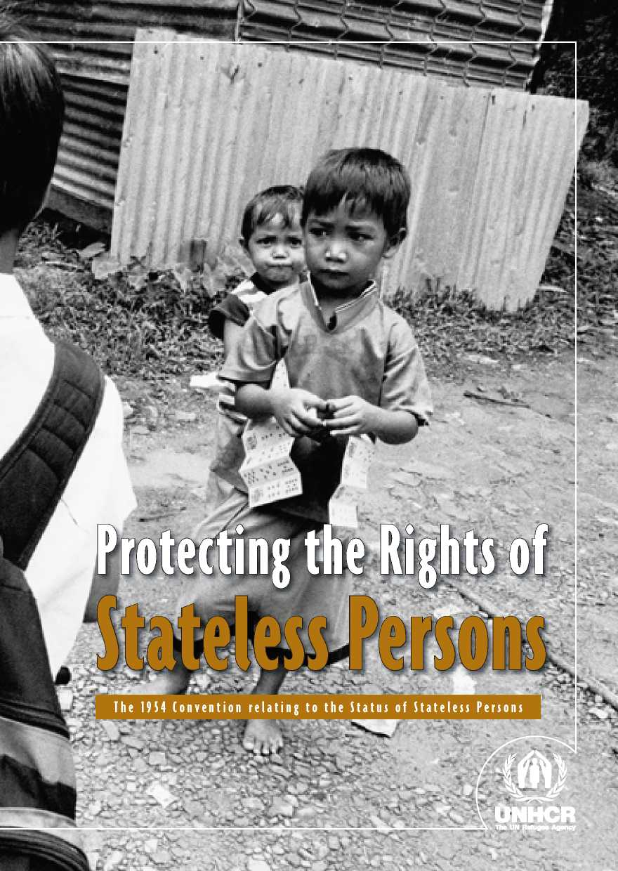

**A PERSONAL APPEAL**

**FROM THE UNITED NATIONS HIGH COMMISSIONER FOR REFUGEES**

Today, millions of people around the world face serious difficulties owing to statelessness. The Convention relating to the Status of Stateless Persons provides a framework for States to assist stateless people - allowing them to live in security and dignity until their situation can be resolved. Presently, very few States are parties to this instrument. We need to change that. I call on States to accede to the Convention and pledge the full support of my Office to governments to help implement its provisions.

Antonio Guterres

PROMOTING RECOGNITION,

ENHANCING PROTECTION

N

ationality is a legal bond between a person and a State. Nationality provides people with a sense of identity but, more importantly, enables them to exercise a wide range of rights. The lack of any nationality, statelessness, can therefore be harmful, in some cases devastating to the lives of the individuals concerned.

Despite international recognition of the right to a nationality, new cases of statelessness have continued to arise. Tackling statelessness still poses a major challenge in the 21st century. There are at least 10 million stateless people around the world today.

While some stateless persons are refugees at the same time, most are not. Stateless persons who are also refugees are entitled to the international protec­tion afforded by the 1951 Convention relating to the Status of Refugees (“1951 Convention”). To address the protection problems faced by stateless persons, in particular those who are not refugees, the international community adopted the 1954 Convention relating to the Status of Stateless Persons (“1954 Convention”). This treaty aims to regulate the status of stateless persons and to ensure the widest possible enjoyment of their human rights. The Convention complements provisions of international human rights treaties.

A growing number of States are turning to the 1954 Convention as a frame­work for the protection of stateless persons. This reflects understanding that the 1954 Convention relating to the Status of Stateless Persons is the only legal instrument that formally establishes the international legal status of “stateless persons”. The Convention also addresses many practical concerns relating to the protection of stateless persons - such as access to travel documents - that are not dealt with elsewhere in international law. While the 1954 Convention had only 65 States Parties on 1 January 2011, more States have been acknowledging that it is a central component of the international regime for enhancing the protection of the rights of stateless persons. Twenty-three States pledged to accede to the Convention at the Ministerial Event organized by the UNHCR in December 2011. By the end of January 2014, 80 States were parties.

WHY DO STATELESS PERSONS  
NEED PROTECTION?

T

he Universal Declaration of Human Rights affirms that “everyone has the right to a nationality”, thereby acknowledging the legal and practical importance of nationality for the enjoyment of human rights. Governments must therefore work to make certain that everyone holds a nationality. Despite this and other provisions of international human rights law, many people never acquire or are deprived of their nationality. When some people remain excluded, their statelessness leaves them vulnerable. Because they lack the bond of nationality with any State, stateless persons need special attention and protection to ensure that they are able to exercise their rights.

For instance, a particular concern for stateless persons is the difficulty that they face in obtaining identity and travel documents, which not only impedes their ability to travel, but can also cause many problems in day-to-day life and may in some cases lead to the prolonged detention of the individual. Statelessness prevents people from fulfilling their potential and may have severe knock-on effects for societal cohesion and stability. It may even cause communal tensions and displacement. Promoting recognition and enhancing protection of stateless persons are means to respond to such concerns.

Stateless people are often without a legal status and feel left out of society. The Galjeel, are a sub-clan of Somali descent and have lived in Kenya since the late 1930s. For decades, the Galjeel held Kenyan ID cards, participated in local and national elections, owned businesses and enjoyed full access to State services. But in 1989 the government introduced a screening system to identify irregular migrants from Somalia. During this process, the authorities confiscated most forms of identification that linked the Galjeel to Kenya. Many became stateless, losing the rights they had enjoyed for decades. Here, a Galjeel boy plays in an abandoned school. Most children in the community do not go to school.

**UNHCR/G. CONSTANTINE**

IS THE 1954 CONVENTION STILL  
RELEVANT IN TODAY'S WORLD?

Y

es, absolutely. Statelessness is still a widespread problem today. With the growing awareness of the global impact of statelessness on individuals and societies, both governments and the international community are increasingly turning to the UN Statelessness Conventions for guidance. The 1954 Convention remains the primary international instrument that regulates the status of non­refugee stateless persons and ensures that stateless persons enjoy human rights without discrimination. It provides stateless individuals with an internationally recognized legal status, offers them access to travel documents, identity papers and other basic forms of documentation, and sets out a common framework with minimum standards of treatment for stateless persons. Accession to the 1954 Convention therefore allows States to demonstrate their commitment to human rights, gives individuals access to protection and mobilizes international support for the State to adequately deal with the protection of stateless persons.

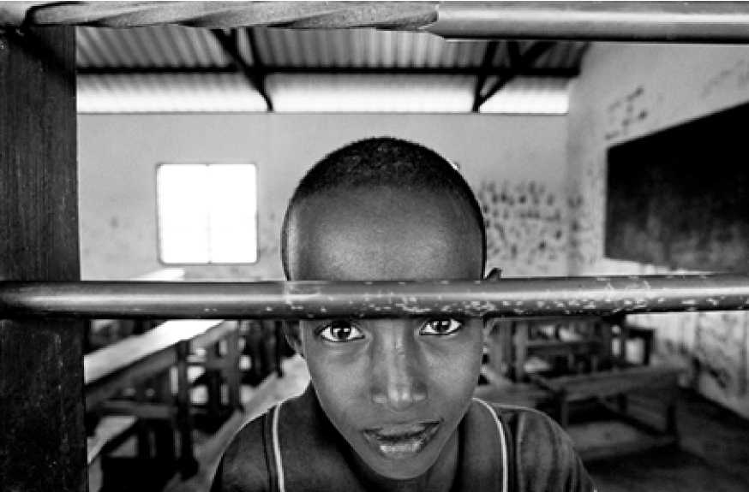

PROTECTING STATELESS PERSONS  
WITH THE 1954 CONVENTION

WHO DOES THE 1954 CONVENTION PROTECT?

The 1954 Convention recognises the international legal status of “stateless persons”. Article 1 establishes the definition of a stateless person in interna­tional law: someone “who is not considered as a national by any State under the operation of its law”. This definition is now also recognised to be custom­ary international law. Establishing whether or not a person is considered as a national under the operation of a country's law, requires a careful analysis of how the State applies its nationality laws in practice. Persons who satisfy the definition are entitled to certain rights and must comply with certain duties contained in the 1954 Convention. The Convention does not cover so-called *de facto* stateless persons for whom no universally accepted definition exists in international law. However, *de facto* stateless persons are entitled to protec­tion under international human rights law. Stateless *refugees* are covered by the 1951 Convention relating to the Status of Refugees and should be treated in accordance with international refugee law.

STATELESS PERSONS' RIGHTS UNDER THE 1954 CONVENTION

T

he 1954 Convention is based on a core principle: no stateless person should be treated worse than any foreigner who possesses a nationality. In addi­tion, the Convention acknowledges that stateless persons are more vulnerable than other foreigners. It therefore provides for a series of special measures for stateless persons.

The 1954 Convention guarantees stateless persons a right to administrative as­sistance (Article 25), a right to identity and travel documents (Articles 27 and 28) and exempts them from reciprocity requirements (Article 7). These tailor- made provisions are designed to deal with the particular difficulties faced by stateless persons due to their lack of any nationality, for instance by providing for a mutually-recognised travel document for stateless persons to function in lieu of a passport. These matters are not regulated elsewhere in international law and are among the core legal benefits for stateless persons under the 1954 Convention.

Considering the plight of stateless people, the Convention stipulates that they must be treated like nationals of the State with regard to certain rights such as freedom of religion or elementary education. It must be stressed that the Convention pursues a nuanced approach, specifying that some guarantees apply to all stateless people while others are reserved to stateless persons lawfully present or lawfully staying in the territory. The 1954 Convention thus echoes human rights standards contained in other international instruments and provides guidance on how such standards are to be implemented for stateless persons. As set out in Article 2 of the 1954 Convention, all stateless persons have the duty to obey the laws and regulations of the country in which they find themselves.

It is important to note that the enjoyment of the rights guaranteed under the 1954 Convention does not equate to possession of a nationality. This is why the 1954 Convention calls upon States to *facilitate* the naturalization (Article 32) of stateless persons. Once they acquire a nationality, stateless persons are no longer stateless: their plight has come to an end.

DOES THE 1954 CONVENTION REQUIRE STATES TO GRANT STATELESS PERSONS

T

he 1954 Convention does not establish a right for stateless persons to acquire the nationality of a specific State. However, because stateless persons have no State to protect them, the Convention requires States Parties to facilitate the integration and naturalization of stateless persons as far as possible, for example by expediting and reducing the costs of naturalization proceedings for stateless persons. At a more general level, human rights law recognises the right to a nationality - set out, for example, in the Universal Declaration of Human Rights. States therefore must strive to avoid statelessness. Moreover, the 1961 Convention on the Reduction of Statelessness provides common, global safeguards against statelessness thereby helping States to ensure the right to a nationality.

WHO DETERMINES WHETHER A PERSON IS STATELESS? HOW IS THIS DONE?-^^^^^^^^M

I

n order to ensure that the rights foreseen in the Convention are extended to stateless persons, States need to be able to identify stateless individuals throughsuitable procedures. The 1954 Convention does not prescribe a particular proce­dure for the determination of whether a person is a stateless person. However, national status determination procedures should offer certain core elements, which are necessary for fair and efficient decision-making in keeping with in­ternational protection standards. These include designating a central authority with the relevant knowledge and expertise to assess applications, procedural safeguards and guarantees at all stages of the process and possibility for appeal or review. UNHCR has been tasked to assist States to establish such procedures.

CAN AN INDIVIDUAL BE EXCLUDED FROM THE PROVISIONS OF THE 1954

T

he 1954 Convention specifies in Article 1 that there are certain circumstances in which the stateless cannot benefit from the status of stateless persons and the protection of the Convention. This is referred to as “exclusion” and ap­plies to individuals who are not in need or are not deserving of international protection, for example because there are serious reasons for considering that they have committed a crime against peace, a war crime, or a crime against humanity. A specific provision applies to a special category of stateless persons, who like other stateless persons are in need of international protection, but for whom separate arrangements have been made to receive protection or assistance.

IS THE 1954 CONVENTION THE ONLY INSTRUMENT RELEVANT ■ O IhE rights of -IaIElEss PeR-UNs;

N

o. Although the 1954 Convention is the only instrument to create a spe­cific status for stateless persons, there is a

substantial body of international human rights law that is also relevant to the rights to be enjoyed by stateless persons. States are already committed to protecting the rights of stateless persons through their human rights obligations. The standards laid down in the 1954 Convention complement and strengthen States' human rights commitments relating to stateless persons. For example, the 1954 Convention establishes a spe­cial regime to provide internationally recognised travel documents to stateless persons.

Despite the efforts of governments, the international community and civil society, statelessness continues to occur. It is therefore essential that the human rights of stateless persons are protected. A bride and her friends travel to the bridegroom's house in Nepal. Even after a major government-run citizenship campaign, thousands of people in Nepal remain stateless or face multiple obstacles to acquiring proof of citizenship. Many are Dalits, such as these women.

**G. CONSTANTINE**

HOW UNHCR ASSISTS STATES TO  
PROTECT STATELESS PERSONS

T

he UN General Assembly selected UNHCR for the task of assisting States to protect stateless persons and to resolve statelessness situations not only because refugee and statelessness problems sometimes overlap, but also because protection of stateless persons requires, in many ways, an approach similar to dealing with refugees. Both populations lack international protection.

UNHCR assists States to implement the 1954 Convention by offering technical advice regarding legislation and operational support to promote the implementation of determination procedures and measures to ensure the rights foreseen in the Convention. UNHCR's Executive Committee has specifically requested the Office to “*actively disseminate information and, where appropriate, train government counterparts on appropriate mechanisms for identifying, recording, and granting a status to stateless persons*” (see UNHCR's Executive Committee Conclusion 106 on *Identification, Prevention and Reduction of Statelessness and Protection of Stateless Persons,* 2006, for more information).



THE IMPORTANCE OF ACCESSION  
TO THE 1954 CONVENTION

A

cceding to the 1954 Convention relating to the Status of Stateless Persons:

**•** Is a way for States to demonstrate their commitment to treat stateless persons in accordance with internationally recognised human rights and humanitarian standards

**•** Ensures that stateless persons have access to the protection of a State so that they are able to live with security and dignity

**•** Provides a framework to identify stateless persons within their territory and ensure enjoyment of their rights, including through issuance of identity documentation and travel documents

**•** Promotes recognition of the international legal status of “stateless person” and the common international framework for protection, thereby increasing legal transparency and predictability in States' response to statelessness

**•** Enhances security and stability by avoiding exclusion and marginalisation of stateless persons

**•** Prevents displacement by promoting the protection of stateless persons in the country in which they find themselves

**•** Helps UNHCR to mobilise international support for the protection of state­less persons

THE LINK WITH THE 1961  
CONVENTION ON THE REDUCTION OF  
STATELESSNESS

N

o matter how extensive the rights granted to a stateless person may be, they are not equivalent to possessing a nationality. All human beings have the right to a nationality and whenever the anomaly of statelessness arises, the focus should be on preventing and reducing it.

Protection of stateless persons under the 1954 Convention relating to the Status of Stateless Persons should thus be seen as temporary response while avenues for the acquisition of a nationality are explored. The reduction of statelessness through acquisition of nationality remains the ultimate goal. The 1961 Conven­tion on the Reduction of Statelessness provides States with tools for avoiding and resolving cases of statelessness.

However, States Parties to the 1961 Convention should still consider acceding to the 1954 Convention to ensure that protective measures are in place when they nevertheless encounter cases of statelessness. Acceding to both the 1954 and 1961 Statelessness Conventions is a key step to equip States to tackle the full range of statelessness problems. More detailed information about the 1961 Convention can be found in *Preventing and Reducing Statelessness - The 1961 Convention on the Reduction of Statelessness* (UNHCR, 2014).



Without valid identity documents stateless persons are often unable to exercise their basic human rights. This is the case for untold thousands 01■ former Soviet citizens who did not meet the legal requirements to obtain the nationality ofa'^BI successor State. Many, like the woman in the picture, ended" up with only an expired USSR passp°rt.

10

Pr o t e c ti n g t h e r i g h ts o f stat e le ss P e r s ons



L = ■<- rrTr» i>• i.-■. -u J 4s£Kri.^ j-- "■■ 'W

UNHCR/G. CONSTANTINE

FREQUENTLY ASKED QUESTIONS  
ABOUT ACCESSION

**QUESTIONS**

**ANSWERS**

Here are answers to some of the most frequently asked questions about accession to the 1954 Convention relating to the Status of Stateless Persons. Further questions and details are discussed in Nationality and Statelessness: A Handbook for Parliamentarians (UNHCR and Inter­Parliamentary Union, 2005, revised second edition forthcoming in 2014).

**G. CONSTANTINE**

n **Does the 1954 Convention compel a State to grant stateless persons entry and/or residence?**

No. The 1954 Convention does not oblige States to admit stateless persons to their territory. However, in practice, there may be no possibility of return to the country of former habitual residence of the individual concerned or there may be no such country. In such cases, admission to the State and some type of legal stay may be the only solution. In addition, other international standards may provide a ground for the admittance or non-expulsion of stateless persons. In particular, States are bound by the prohibition of *refoulement* as a principle of international law and may not return a stateless person to a territory where he or she would be at risk of persecution or breaches of other fundamental international human rights standards, including torture and arbitrary deprivation of life.

n **What is the difference between a stateless person and a refugee?**

Stateless persons and refugees are both in need of international protection. They find themselves in a precarious situation because the link with the State has been broken. Both, therefore, enjoy a special yet separately defined status under international law. A key element of the definition of a refugee is that he or she has a *well-founded fear of persecution*. Being stateless does not necessarily signify persecution. As well, to be a refugee, a stateless person must also be outside of his or her country of habitual residence. Yet most stateless persons have never left the country where they were born. However, statelessness is often a root cause of forced displacement. When stateless persons are also refugees they are covered by the 1951 Convention relating to the Status of Refugees and international refugee law.

n **Are States obliged to treat stateless persons equal to their own nationals?**

On the coast of Bangladesh, a group of refugees from northern Rakhine State in Myanmar push their fishing boats out to sea. Most stateless persons are not refugees but those who are must be treated in accordance with international refugee law.

No. With respect to most of the rights enumerated in the 1954 Convention relating to the Status of Stateless Persons, stateless persons should enjoy at least the same rights guaranteed to other non-nationals. Moreover, the Convention extends a number of rights only to those stateless persons who are *lawfully* in the territory or *lawfully staying.* In a limited number of cases - such as with respect to the freedom of religion and access to courts - States must accord to stateless persons the same treatment as enjoyed by nationals. International human rights law complements the provisions of the 1954 Convention and in many instances human rights treaties provide for higher standards of treatment for stateless persons.n Can a State adopt reservations to the provisions of the 1954 Convention?

Yes. Reservations are permitted at the time of ratification or accession, except to Article 1 (the definition of a stateless person and the exclusion clauses), Article 3 (non-discrimination), Article 4 (freedom of religion), Article 16(1) (access to courts), and Articles 33 to 42 (final clauses).

n **What practical considerations are involved in acceding to the 1954 Convention?**

As States have already undertaken obligations under international human rights instruments which apply to stateless persons, they will find it easier to implement many of the rights contained in the 1954 Convention. However, in order to ensure that stateless persons enjoy the rights laid down in the 1954 Convention, States need to establish some form of status determination procedure in order to identify stateless persons who may benefit from the Convention. The 1954 Convention does not prescribe a particular procedure for the determination of whether a person is a stateless person. States define the institutions and/or authorities involved, the stages of the process, as well as the procedural safeguards and guarantees which need to be in place to ensure compliance with international standards of due process. UNHCR has published guidelines on procedures for determining when an individual is a stateless person. UNHCR's Executive Committee has indicated that the Office should provide technical advice to States Parties on the implementation of the 1954 Convention so as to ensure consistent implementation of its provisions. The 1954 Convention also requires that States Parties provide information on the domestic laws and regulations through which the terms of the Convention are implemented (Article 33).

n **How does a State accede to the 1954 Convention?**

States may accede to the 1954 Convention relating to the Status of Stateless Persons at any time by depositing an instrument of accession with the Secretary-General of the United Nations. The instrument of accession must be signed by the Foreign Minister or the Head of State or Government. Further details on accession procedures and model instruments of accession can be found at [www.unhcr.org/statelessness](http://www.unhcr.org/statelessness).

INTERNATIONAL CALLS FOR ACCESSION

**UN General Assembly:** *Welcomes* pledges by States to accede to the statelessness con­ventions, the 1954 Convention relating to the Status of Stateless Persons and the 1961 Convention on the Reduction of Statelessness, as well as pledges to remove reserva­tions to them, also welcomes the recent increase in the number of accessions to the two Conventions [...]

* *General Assembly Resolution 67/149, Office of the United Nations High Commissioner for Refugees, 20 December 2012*

**UN Human Rights Council:** *Acknowledges* that 2011 will mark the fiftieth anniversary of the Convention on the Reduction of Statelessness, and encourages States that have not acceded to the Convention and to the Convention relating to the Status of Stateless Persons to consider doing so.

* *Human Rights Council Resolution 13/02, Human rights and arbitrary deprivation of nationality, 24 March 2010*

**UNHCR Executive Committee:** *Encourages* States to give consideration to acceding to the 1954 Convention relating to the Status of Stateless Persons and, in regard to States Parties, to consider lifting reservations.

* *Conclusion No. 106 (LVII) - 2006*

**Asian-African Legal Consultative Organization:** *Invites* Member States to consider the possibility of acceding to the 1954 Convention relating to the Status of Stateless Persons and the 1961 Convention on the Reduction of Statelessness to address the plight of stateless persons in an effective way.

* *Resolution on the Half-Day Special Meeting on “Legal Identity and Statelessness”, 8 April 2006* **General Assembly of the Organization of American States:** *Resolves 1.* To invite those member states that have not yet done so to consider ratifying or acceding to, as the case may be, the international instruments in the area of stateless persons, and to promote the adoption of procedures and institutional mechanisms for their application, in ac­cordance with those instruments. 2. To emphasize the importance of the international instruments for the protection of stateless persons and for the prevention and reduction of statelessness, and to urge member states to follow up on the specific commitments entered into during the celebration of the 50th anniversary of the Convention on the Reduction of Statelessness, with technical support from the Office of the United Na­tions High Commission for Refugees (UNHCR).
* *Resolution of the General Assembly, AG/RES. 2787 (XLIII-O/13), Prevention and Reduction of Statelessness and Protection of Stateless Persons in the Americas, 5 June 2013*

**MODEL INSTRUMENT OF  
ACCESSION TO THE CONVENTION  
RELATING TO THE STATUS OF  
STATELESS PERSONS OF 1954**

WHEREAS a Convention relating to the Status of Stateless Persons was adopted by the Conference of the Plenipotentiaries on the twenty-eighth day of Sep­tember, one thousand nine hundred and fifty-four, and is open for accession pursuant to Article 35 thereof;

AND WHEREAS, it is provided in section 4 of the said Article 35 that acces­sion thereto shall be affected by deposit of an instrument with the Secretary General of the United Nations;

NOW THEREFORE, the undersigned, [Title of Head of State, Head of Government or Foreign Minister] hereby notifies the accession of the [State concerned];

GIVEN under my hand in this day of two

thousand and .

[Public Seal and Signature of custodian if appropriate]

[Signature of Head of State, Head of Government or Foreign Minister]

I would like more information about:

G. CONSTANTINE

Cover:

Stateless children are often unable to obtain primary education. For several decades, the State of Sabah in Malaysia has been host to refugees from the Philippines and migrants from Indonesia and the Philippines. The children of these groups often end up stateless. While children who possess the right documents are able to attend school, those who don't, like the two boys on the right, are left out of most public programmes.

**UNHCR**

**The UN Refugee Agency**

**UNHCR and its work on statelessness**

Visit UNHCR's statelessness website at [www.unhcr.org/statelessness](http://www.unhcr.org/statelessness). You can also consult relevant Conclusions on International Protection of UNHCR's Executive Committee, in particular Conclusion 106 on *Identification, Prevention and Reduction of Statelessness and Protection of Stateless Persons* (2006).

**International law relating to the protection of stateless persons, including the 1954 Convention relating to the Status of Stateless Persons**

For a more detailed discussion of the 1954 Convention as well as other international norms relating to the protection of stateless persons, see *Nationality and Statelessness:* A Handbook for Parliamentarians (UNHCR and Inter-Parliamentary Union, 2005, revised second edition forthcoming in 2014). For a detailed commentary on the 1954 Convention, see *Convention relating to the Status of*

*Stateless Persons - Its History and Interpretation* (Robinson, 1955), and *UNHCR Guidelines on Statelessness* on the definition of “Stateless Person” in Article 1(1) of the 1954 Convention relating to the Status of Stateless Persons; Procedures for Determining whether an Individual is a Stateless Person; and the Status of Stateless Persons at the National Level. To access these and other relevant international documents on statelessness, visit UNHCR's Refworld website at <http://www.refworld.org/> statelessness.html

Published by:

UNHCR

P.O. Box 2500 1211 Geneva 2 Switzerland

UNHCR, January 2014

